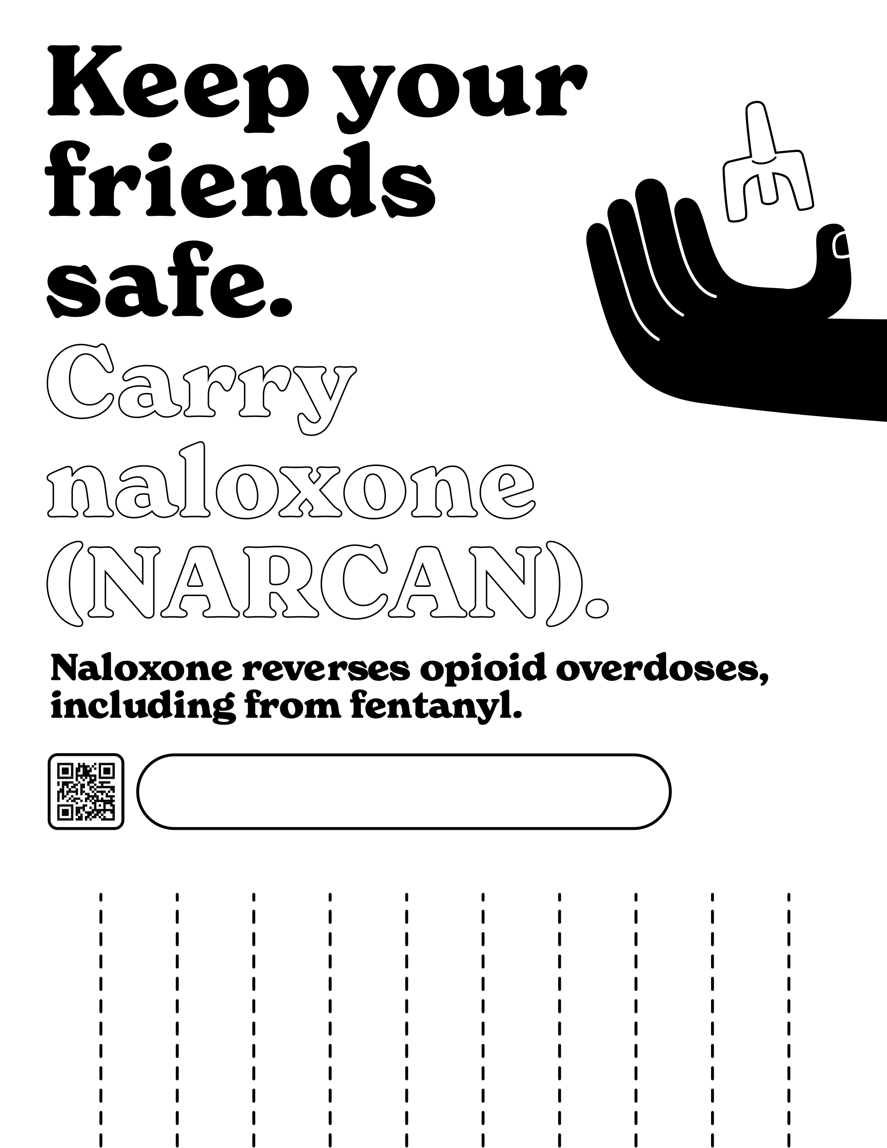

Room for customization.

SSP logos, addresses and hours are a possible suggestion

Learn where to find free naloxone

Call (000) 000-0000 or

Visit CustomSSP.com

Learn where to find free naloxone

Call (000) 000-0000 or

Visit CustomSSP.com

Learn where to find free naloxone

Call (000) 000-0000 or

Visit CustomSSP.com

Learn where to find free naloxone

Call (000) 000-0000 or

Visit CustomSSP.com

Learn where to find free naloxone

Call (000) 000-0000 or

Visit CustomSSP.com

Learn where to find free naloxone

Call (000) 000-0000 or

Visit CustomSSP.com

Learn where to find free naloxone

Call (000) 000-0000 or

Visit CustomSSP.com

Learn where to find free naloxone

Call (000) 000-0000 or

Visit CustomSSP.com

Learn where to find free naloxone

Call (000) 000-0000 or

Visit CustomSSP.com

Learn where to find free naloxone

Call (000) 000-0000 or

Visit CustomSSP.com

Learn where to find free naloxone

Call (000) 000-0000 or

Visit CustomSSP.com